F=ma worksheet
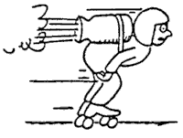
Use the following information to answer the next six questions.

1. Mr. Lindsay the roller-blader, total mass 100 kg, is propelled by rocket power.

Complete Table I. (neglect any resistance)

Force  (N) | acceleration  (m/sec²)
200
400
500

- Complete Table II for a constant 200-N resistance.

Force  (N) | acceleration  (m/sec²)
200
400
500

Refer to the following information for the next five questions.

- Block A on a horizontal friction-free table is accelerated by a force from a string attached to Block B. B falls vertically and drags A horizontally. Both blocks have the same mass m. (Neglect the string’s mass).
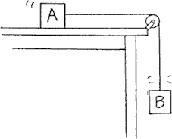
  - The mass of the system [A+ B] is .

m | 2m

  - The force that accelerates [A + B] is the weight of .

A | B | A + B

  - The weight of B is .

½ mg | mg | 2mg

  - Acceleration of [A + B] is .

less than g | g | more than g

  - Calculate the exact acceleration of [A + B] in m/sec²
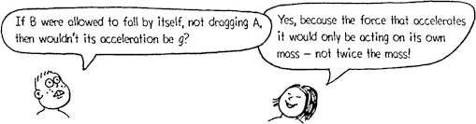

Refer to the following information for the next three questions.

- Suppose A is still a 1-kg block, but B is a low-mass feather (or a coin).

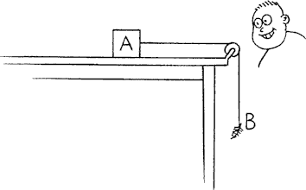
  - Compared to the acceleration of the previous system, the acceleration of [ A + B ] here is ,

less | more

and is

close to zero | close to g

Refer to the following information for the next two questions.
- Suppose A is a feather, or coin, and B has a mass of 1-kg.
- In this case the acceleration of B is
.

practically that of free fall | constrained

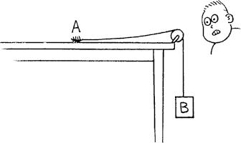
  - The acceleration of [A + B] here is
.

close to zero | close to g

  - In this case the acceleration of B is
.

practically that of free  fall | constrained

Summarizing the three cases we have examined, where the weight of one object causes the acceleration of two objects, we see the range of possible accelerations is

between zero and g
between zero and infinity
between g and infinity

Refer to the following information for the next three questions.

6. A ball rolls down a uniform-slope ramp.

  - Acceleration is .

decreasing | constant | increasing

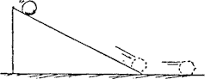
b If the ramp were steeper, acceleration would be
.

more | the same | less

c When the ball reaches the bottom and rolls along the smooth level surface it .

continues to accelerate | does not accelerate

7. Fill in the magnitudes of net force for each case. The magnitude and direction of each original vector is given.
 | Question a | Question b

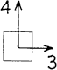 | 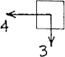
Question c | Question d

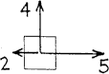 | 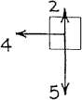
Question e | Question f

- Which of the following objects has the greatest inertia?
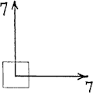 | 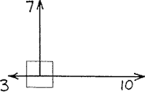
Question g | Question i
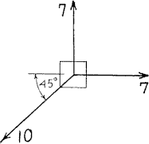 | 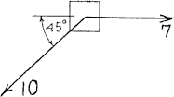
Question j | Question k

a 2-kg mass moving at a constant velocity of 100 m/s, E
a 4-kg mass moving at a constant velocity of 2 m/s, E
a 2-kg mass moving at a constant velocity of 20 m/s, E
a 6-kg mass at rest

Explain why you made your choice

.

- Which object could be moving with constant velocity along a straight line path if the only forces acting on it are those shown in each diagram?
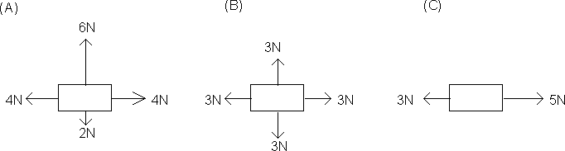

A | B | C

Explain why you made your choice.

- A certain force F gives a mass M an acceleration of a. The same force F would therefore give a mass of 2M an acceleration of .

2a | a | a/2 | a/4

Explain why you made your choice.

- A certain force F gives a mass M an acceleration of a. A force of 6F would therefore give a mass of
2M an acceleration of .

12a | 3a | a | a/3

Explain why you made your choice.

- Which of the following objects is more massive?

A force F of 100 N pulls to the right causing this mass to accelerate at 25 m/sec² to the right
A force F of 50 N pulling to the right causes this object to accelerate to the right at 10 m/sec²

Explain why you made your choice.

- What is the magnitude (size) of the missing force in the figure diagrammed below?
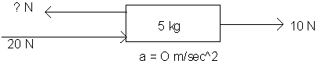

10 N | 20 N | 30 N | 40 N

Explain why you made your choice.

- What is the magnitude (size) of the missing force in the figure diagrammed below?
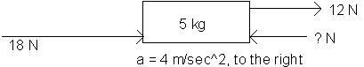

10 N | 14 N | 20 N | 30 N

Explain why you made your choice.

- Bronco skydives and parachutes from a stationary helicopter. Various stages of fall are shown in positions a through f in the table shown below. Using Newton's 2nd law, find Bronco's acceleration at each position.

a = net F/m

a = (W - R)/m

You need to know that Bronco's mass, m, is 100 kg so his weight, W, is a constant 1000 N. Please use the approximation, g = 10 m/sec². Air resistance R varies with speed and cross-sectional area.

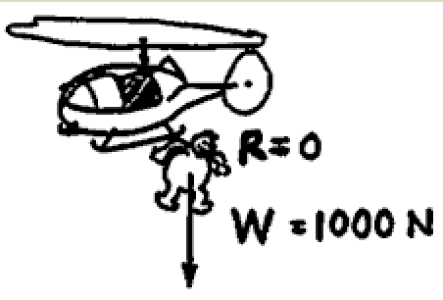
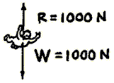
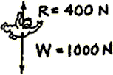
b
a
c

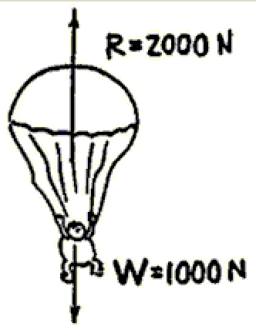
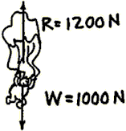
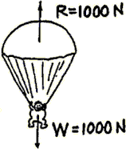
d f
e

Position | Acceleration (m/s²)
a
b
c
d
e
f

a. When Bronco's speed is least, his acceleration is .

least | most

- In which position(s) does Bronco experience a downward acceleration?

a | b | c | d | e | f

- In which position(s) does Bronco experience an upward acceleration?
a | b | c | d | e | f

- When Bronco experiences an upward acceleration, his velocity is .

still downward | upward also

- In which position(s) is Bronco's velocity constant?
a | b | c | d | e | f

- In which position(s) does Bronco experience terminal velocity?
a | b | c | d | e | f

- In which position(s) is terminal velocity greatest?
a | b | c | d | e | f

- If Bronco were heavier, his terminal velocity would be .

greater | less | the same

Refer to the following information for the next three questions.

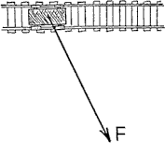
- The sketch shows a top view of a small railroad car pulled by a rope. The force F that the rope exerts on the car has one component along the track, and another component perpendicular to the track.

  - Sketch these components on a piece of paper. Which component is larger?

  - Which component produces acceleration?

  - What would be the effect of pulling on the rope if it were perpendicular to the track?

Refer to the following information for the next three questions.

17. The sketches below represent simplified top views of sailboats in a cross-wind direction. The impact of the wind produces a FORCE vector on each as shown. (We do NOT consider velocity vectors here!)

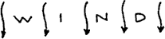
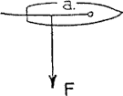

- Why is the position of the sail above useless for propelling the boat along its forward direction?

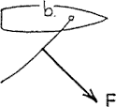

- Sketch the component of force parallel to the direction of the boat's motion (along its keel), and the component perpendicular to its motion. Will the boat now move in a forward direction?

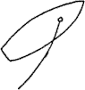

- The boat shown above is oriented at an angle into the wind. On a sheet of paper, draw the force vector and its forward and perpendicular components. Will the boat move in a forward direction and tack into the wind? Why or why not?

Refer to the following information for the next four questions.

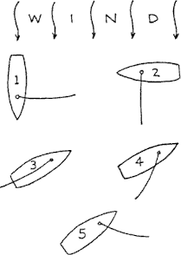
- The sketch below is a top view of five identical sailboats. Where they exist, draw force vectors to represent wind impact on the sails. Then draw components parallel and perpendicular to the keels of each boat.

  - Which boat will sail the fastest in a forward direction?

  - Which will respond least to the wind?

  - Which will move in a backward direction?

  - Which will experience less and less wind impact with increasing speed?

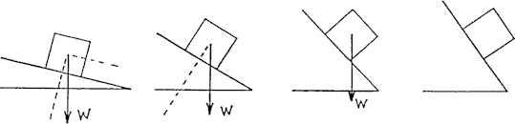
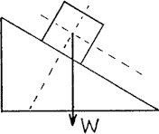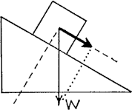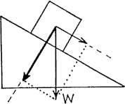

Weight of the block is represented by vector W. We show axes parallel and  perpendicular to the surface of the inclined plane. | W has a component parallel to the surface (bold vector). Acceleration down the incline is due to this component. | W also has a component perp. to the surface (bold vector). This component gives the force pressing the block against the surface, and is equal and opposite  to the normal force (not shown).

Refer to the following information for the next two questions.

- Here is the same block on a steeper incline. Draw in the components.
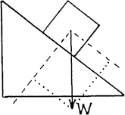
- For a steeper incline, the component parallel to the incline is .

greater | the same | less

- For a steeper incline, the component perpendicular to the incline .

increases | stays the same | decreases

- Practice drawing the components of each weight vector parallel and perpendicular to the surface for the blocks shown below.
  - B. C. D.
a. At which location is the component parallel to the ramp surface greatest?
b. At which location is the acceleration of the block along the ramp greatest?
- At which location is the acceleration of the block along the ramp least?
- At which location is the acceleration of the block along the ramp most?

